1.Configuration of Network Devices using Packet Tracer tools (Hub, Switch, Ethernet, Broadcast)

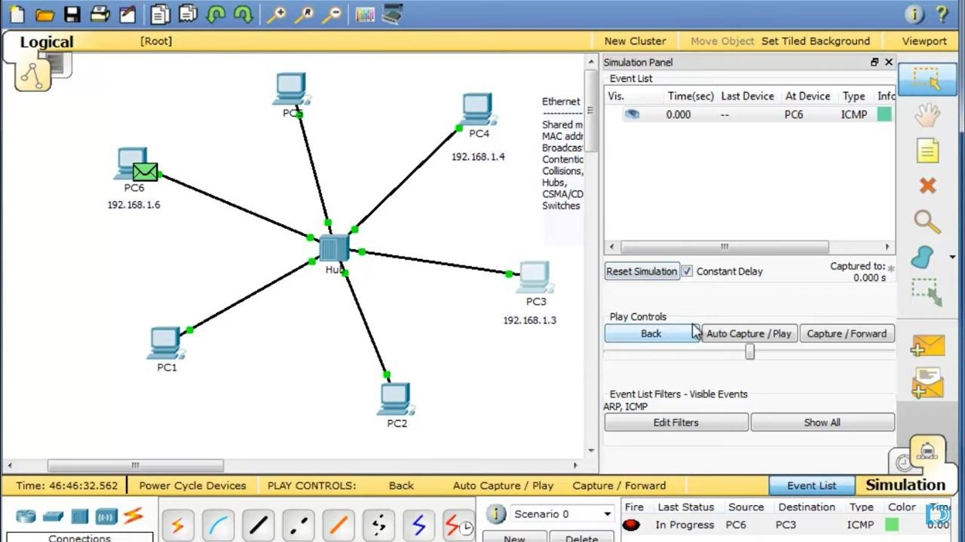

1. Design and Configuration of Star Topologies using Packet Tracer Star Topology using Hub:

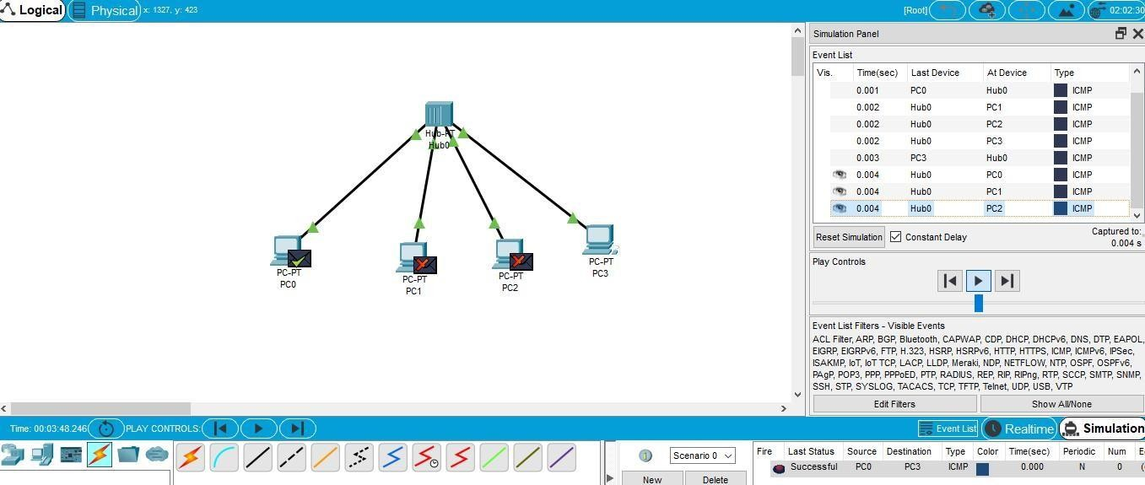

Star Topology using Switch:

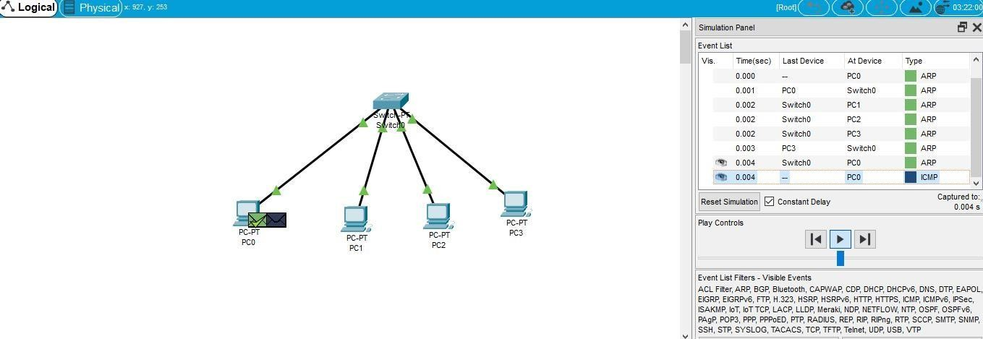

1. Design and Configuration of BUS Topologies using Packet Tracer.

Bus Topology using Hub:

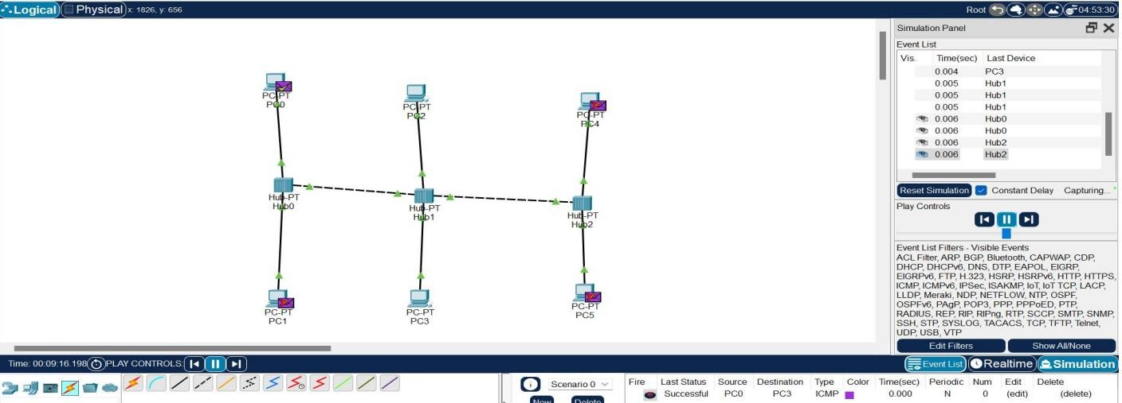

Bus Topology using Switch:

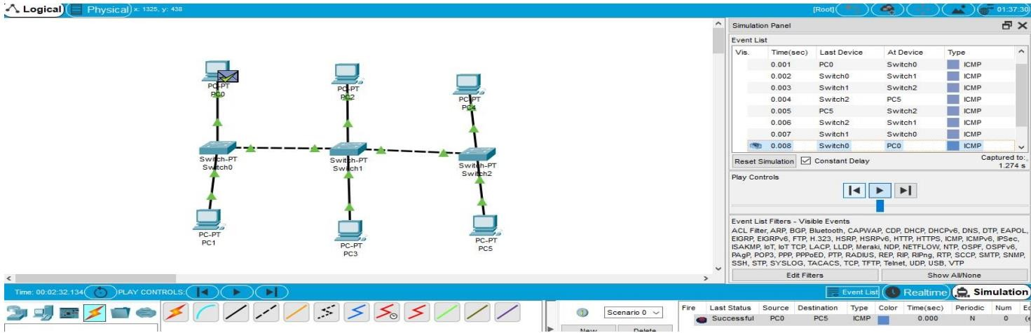

1. Design and Configuration of RING Topologies using Packet Tracer

Ring Topology using Hub:

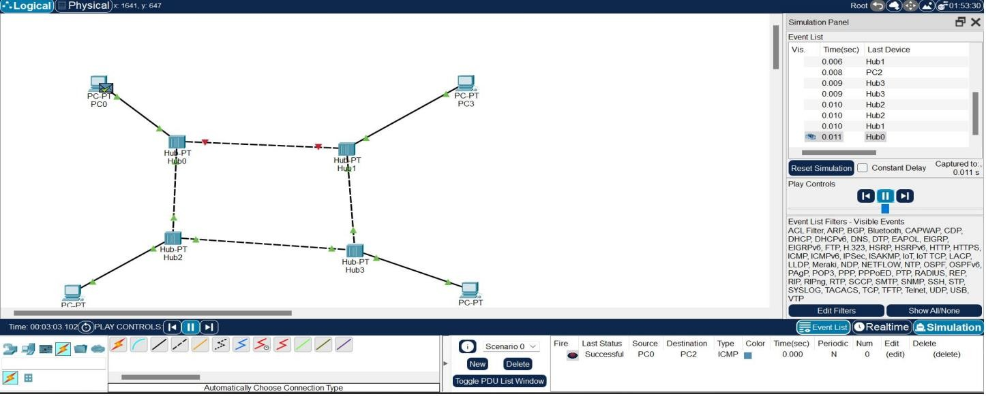

Ring Topology using Switch:

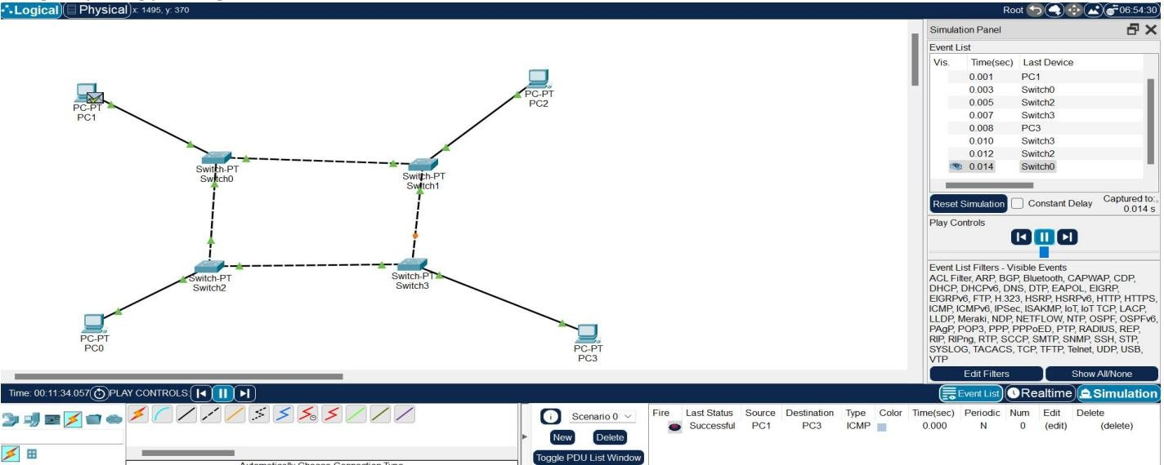

1. Design and Configuration of Mesh Topologies using Packet Tracer Mesh Topology using Hub:

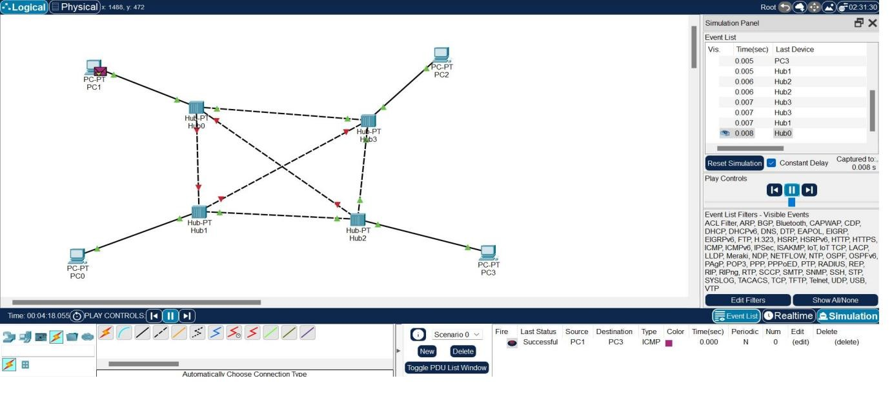

Mesh Topology using Switch:

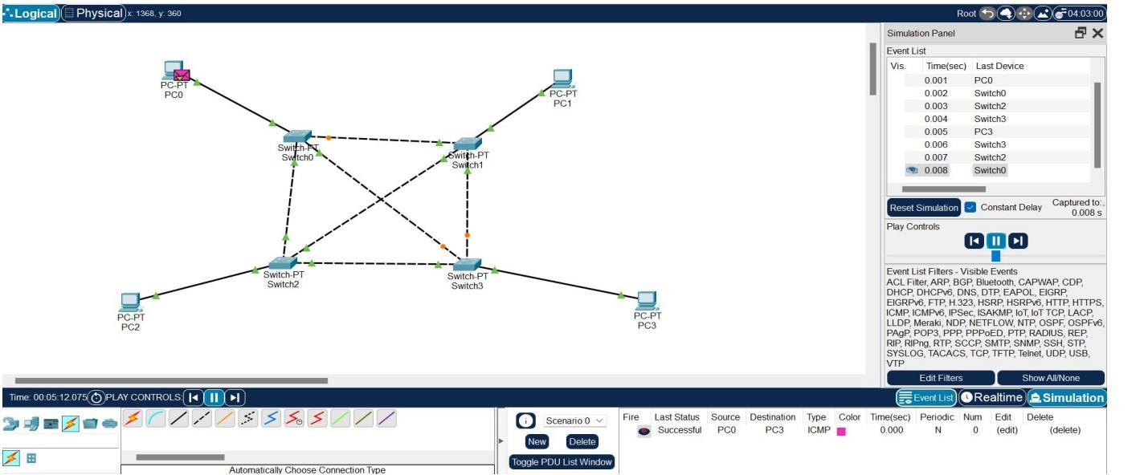

6.Design and Configuration of Tree Topologies using Packet Tracer.

Tree Topology using Hub:

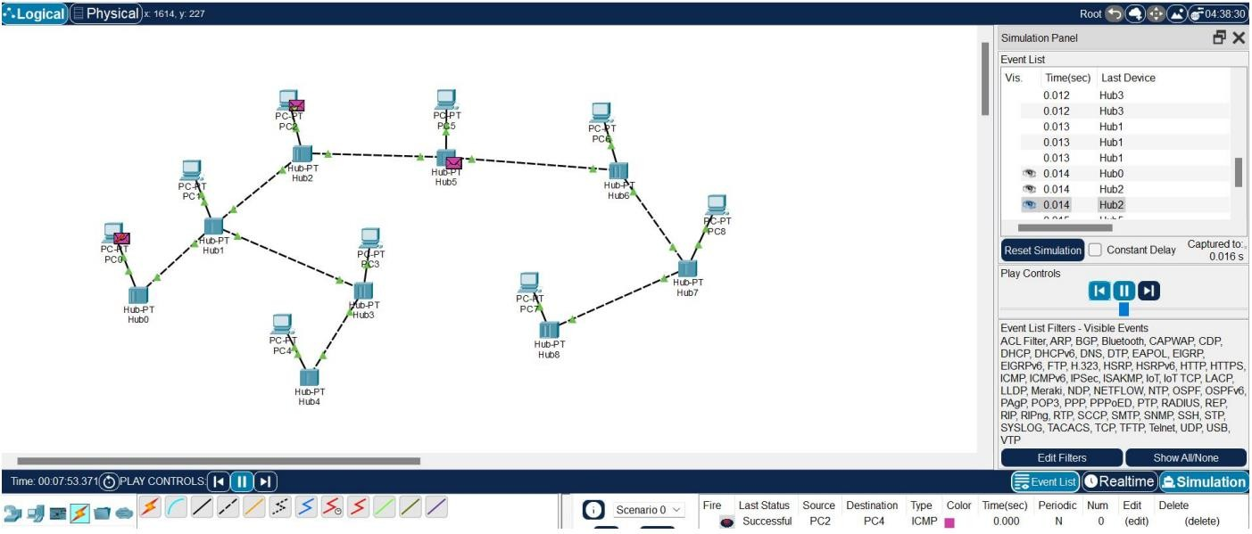

Tree Topology using Switch:

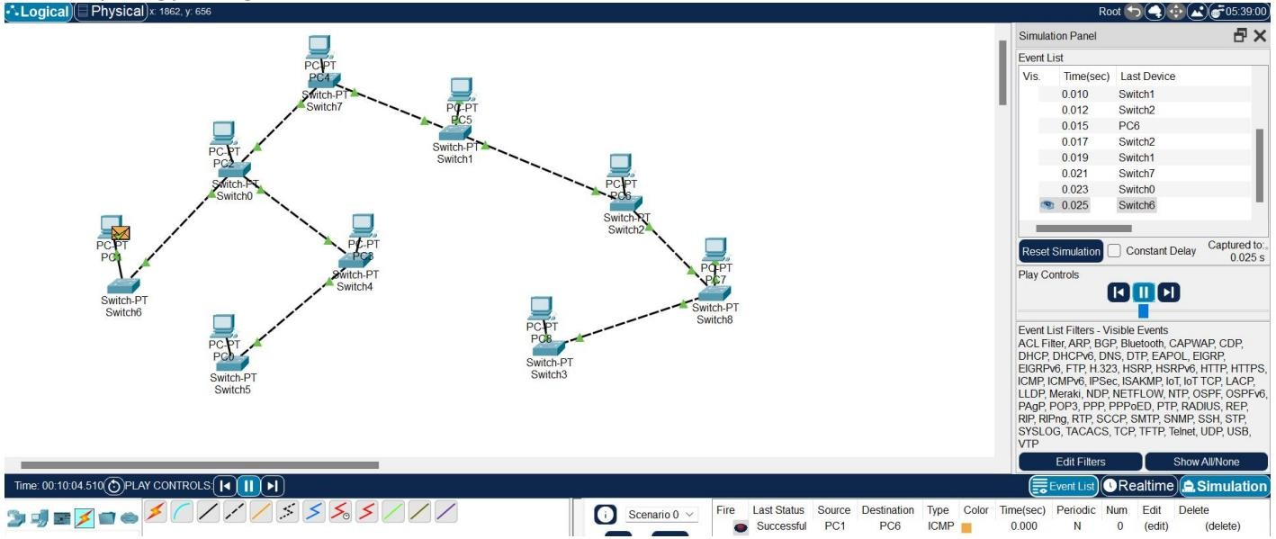

1. Design and Configuration of Hybrid Topologies using Packet Tracer

Hybrid Topology using Hub:

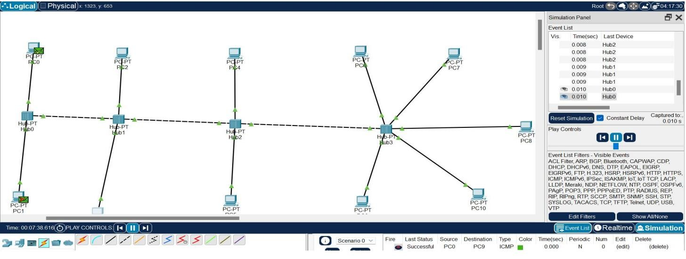

Hybrid Topology using Switch:

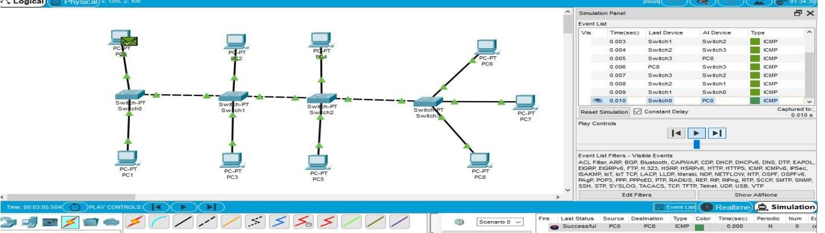

1. Data Link Layer Traffic Simulation using Packet Tracer Analysis of ARP

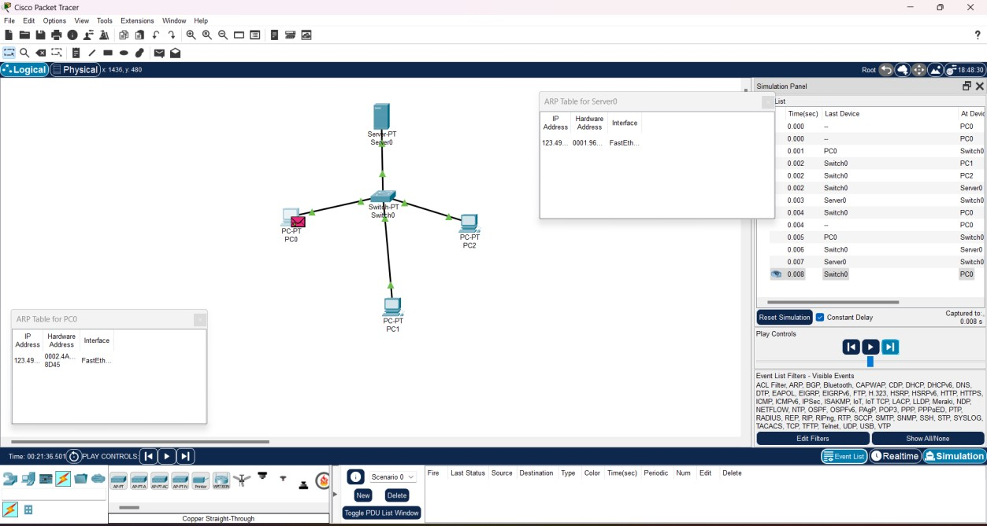

1. Data Link Layer Traffic Simulation using Packet Tracer Analysis of LLDP

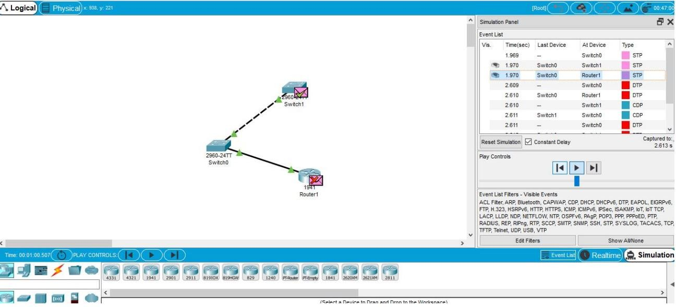

1. Data Link Layer Traffic Simulation using Packet Tracer Analysis of CSMA/CD & CSMA/CA

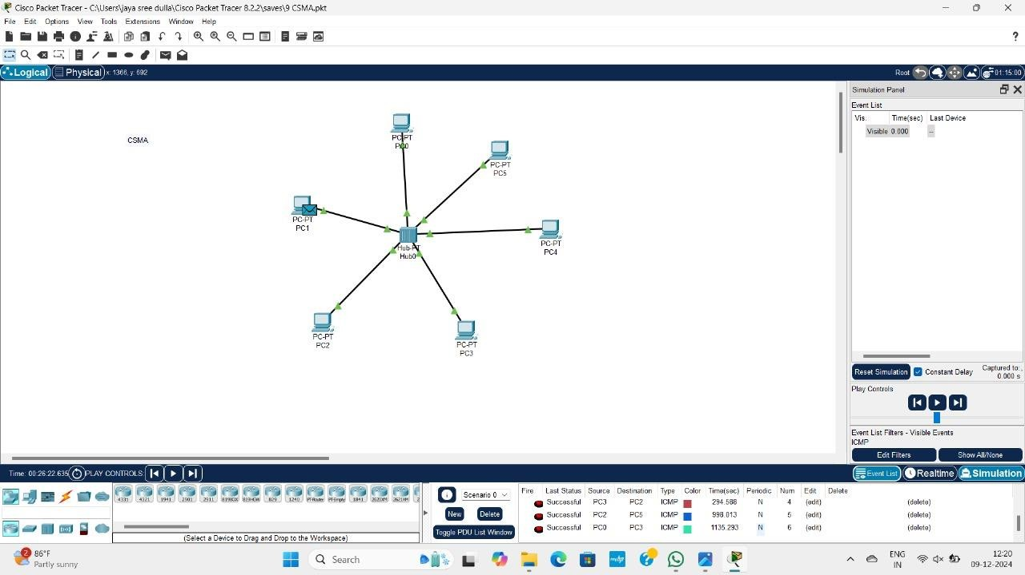

11.Designing two different networks with Static Routing techniques using Packet Tracer.

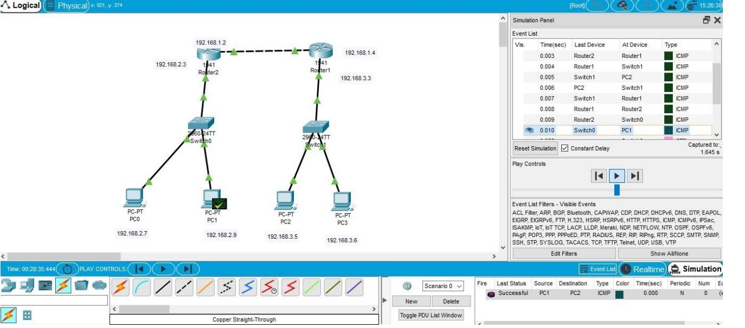

12.Designing two different networks with Dynamic Routing techniques (RIP & OSPF) using Packet Tracer

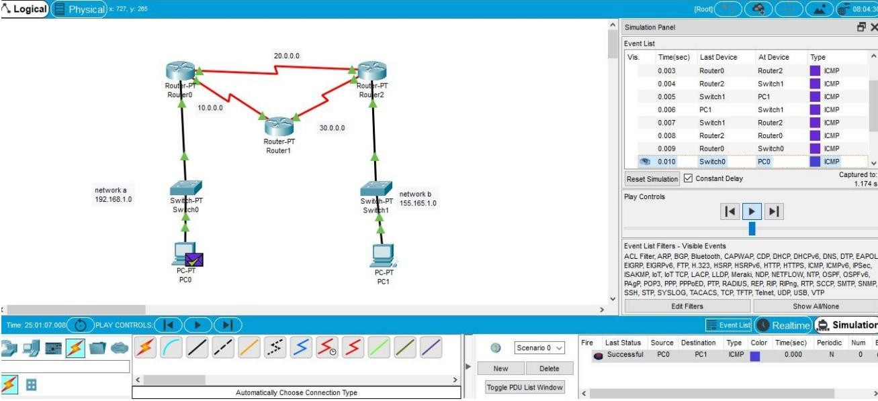

13.Design the Functionalities and Exploration of TCP using Packet Tracer

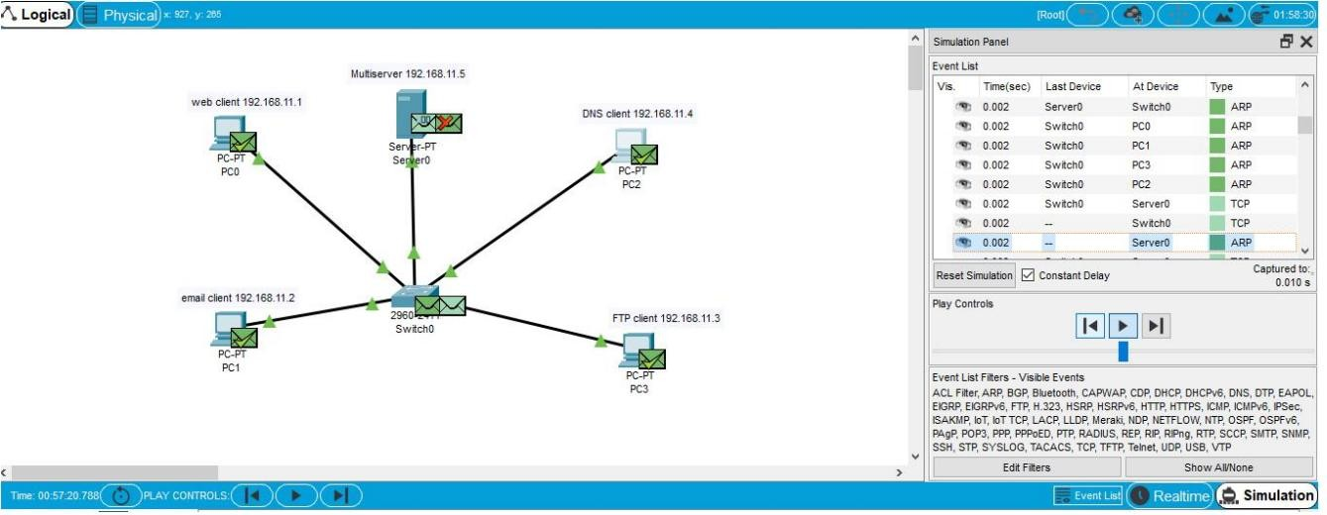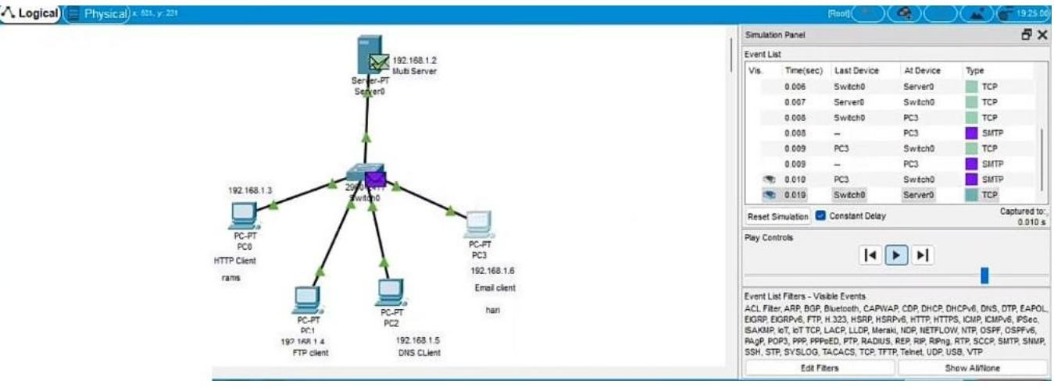

14.Design the Functionalities and Exploration of UDP using Packet Tracer.

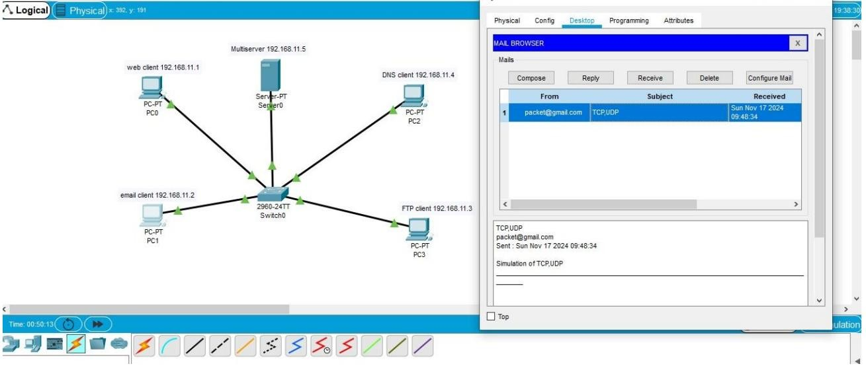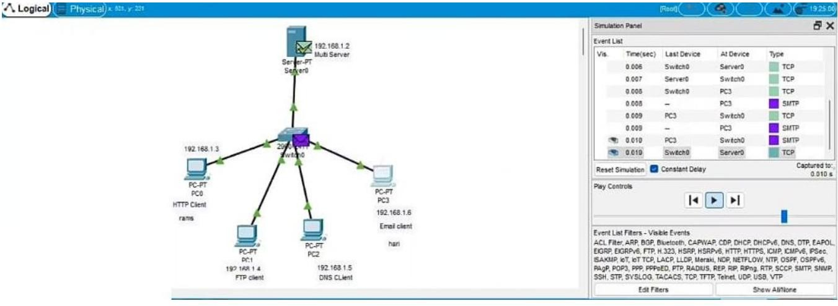

1. Design the network model for Subnetting – Class C Addressing using Packet Tracer.

